**ASSIGNMENT 1**

**INTRODUCTION**

I’ve selected the topic mobile phones for my assignment given to me. The website that I’ll be creating will include a range of latest technology and latest trending models of mobile phone in the current market.

In the world of technology, every household would be having at least 1 mobile phone. Mobile phone is no longer just a phone which are capable of making phone calls and texts, developers are inventing more usage and functions to attract user in getting a cell phone. In every minute, you’ll see user sticking themselves to their phone, be it to reply emails, to play games/music/videos, take images or to surf the web. All these functions are available in a palm size phone, and that’s the reason why mobile phones are getting more popular in the market and this is the main reason which motivate me to start my project with this topic.

The idea of the theme for my website will be from <https://www.engadget.com/>

The design guideline for my website will be **Visibility of system status**, **Accessibility** and **Consistency**.

**Visibility of system status**

* Which allow visitor to easily understand the very first thing when they enter the website

**Accessibility**

* A search button which allow visitor to easily navigate to their desire page by typing keyword.

**Consistency**

* To ensure that graphic must not be misleading to non-related page

**THE STORYBOARD**

HOME

CONTACT US

NEWS

PRODUCTS

ABOUT US

**HOME**

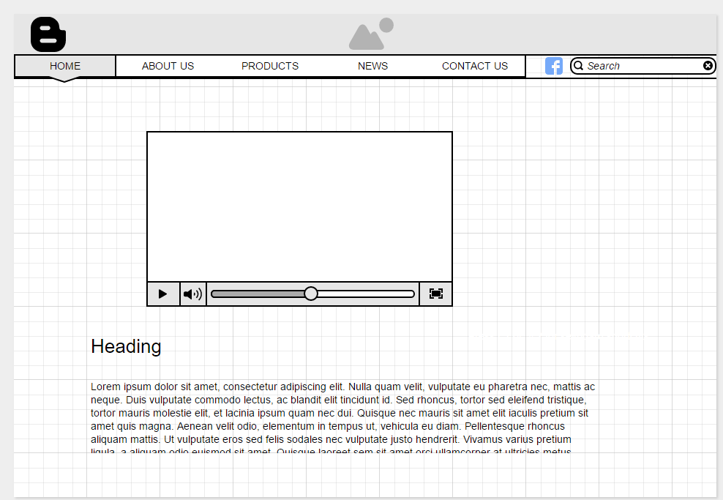

In the home page, I’ve inserted a video which display the latest phone model followed by some description and features of the phone which will allow user to have a better understanding of the featured phone.

**ABOUT US**

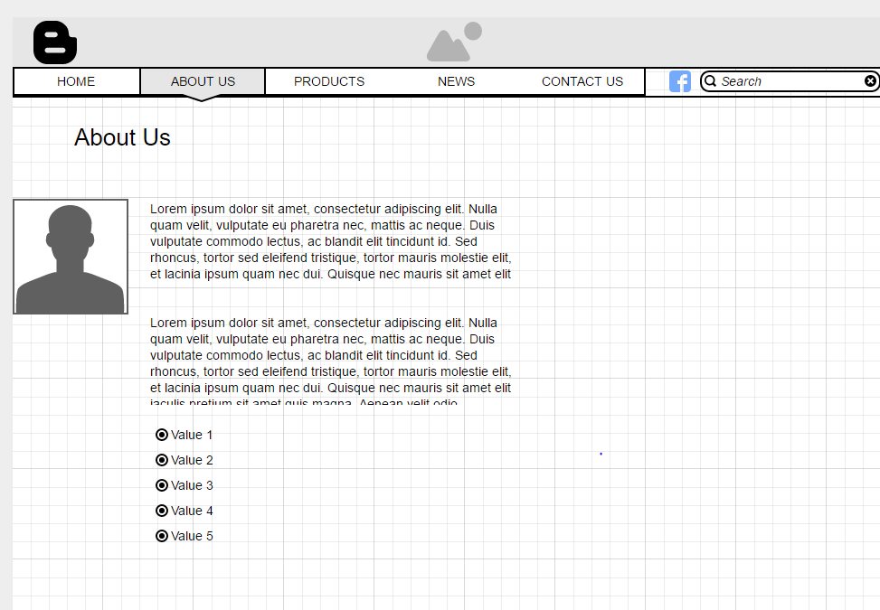

On the second tab, I’ve inserted an image of the company executive, paragraph with short introduction of the company information, ending it with 5 company’s core value.

**PRODUCTS**

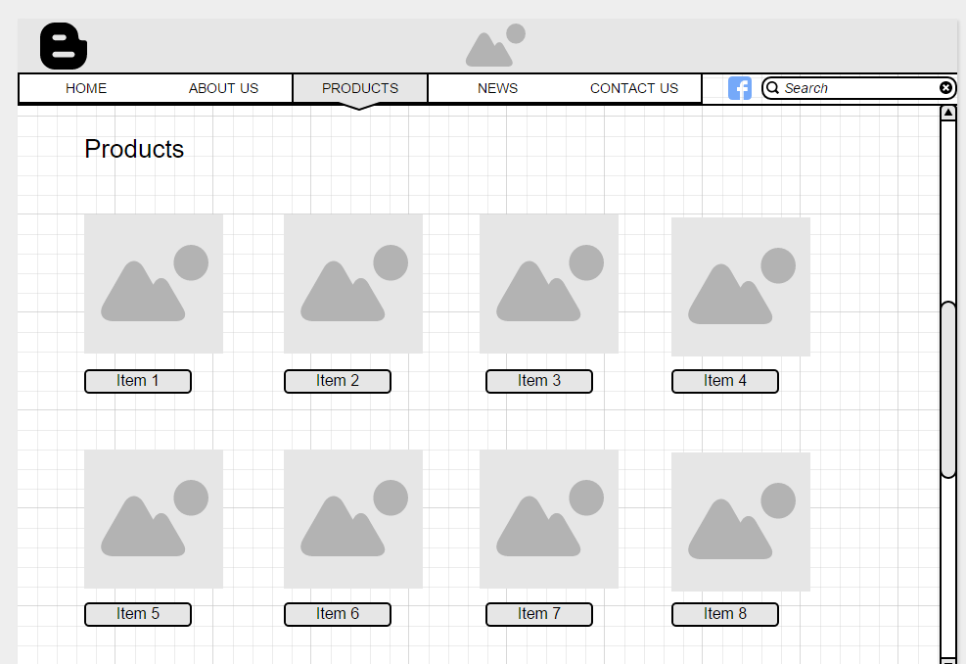

For the products tab, it will feature various model of phones with a button below the image which will list out more description of that phone model provided for visitors.

**NEWS**

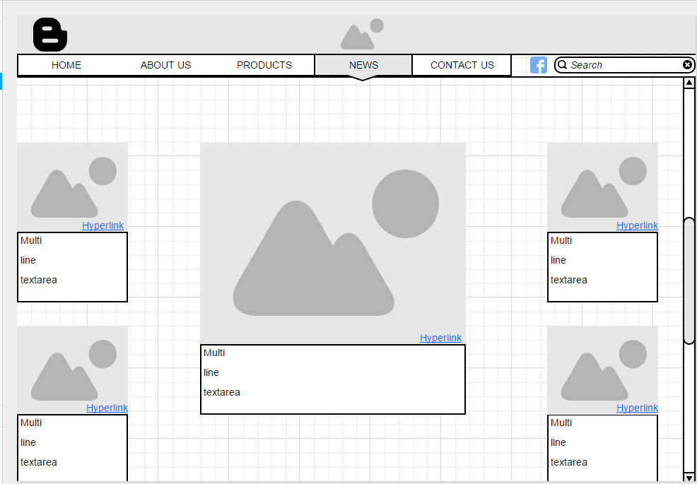

For the news tab, On the both sides, there will be popular news which is relevance to certain phones, the latest news and updates on popular phones will be featured in the center of the page with short introduction of the news. A hyperlink which will bring visitor to a new tab which provide more details of the news.

**CONTACT US**

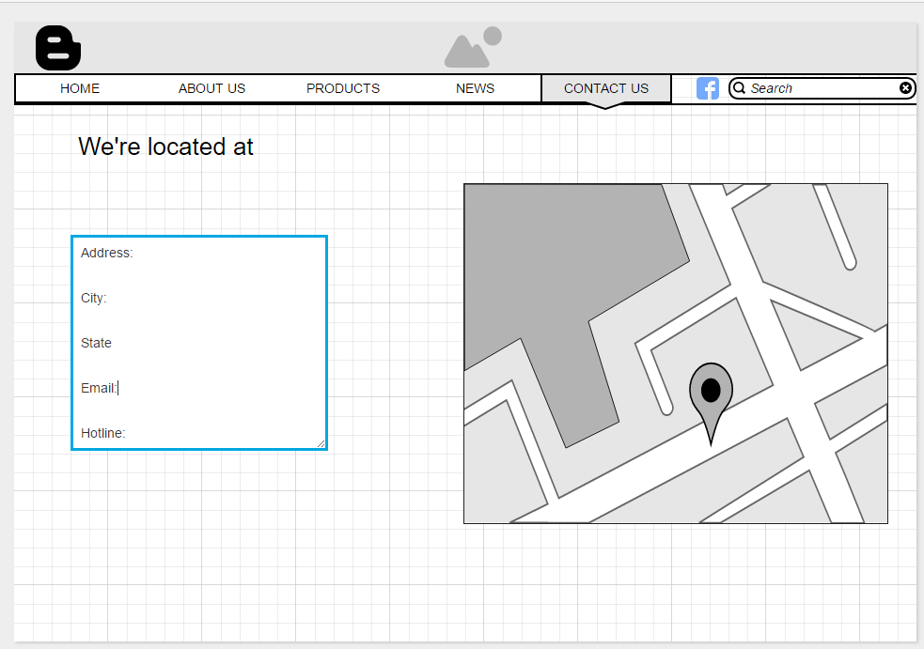

On the last tab, company contact information and exact location are display which allow visitor to easily navigate.

**REFERENCES**

Ellis, M. (2016). *The 8 best free web design ebooks*. *Creative Bloq*. Retrieved 15 October 2016, from <http://www.creativebloq.com/web-design/10-best-free-ebooks-2015-web-designers-121518462>

Website Design - GMN Web Solutions. (2016). GMN Web Solutions. Retrieved 15 October 2016, from <http://www.gmnwebsolutions.com/website-design/?url=http://www.gmnwebsolutions.com/website-design/&source=SearchNetwork&keyword=mobile%20web%20design&matchtype=e&device=c&gclid=Cj0KEQjwp4fABRCer93Klpaki94BEiQAsXJMGoQiCQ2KmEot8ul-JpOvkeizKPQg3h-HBuLA4hVL-BoaAhpE8P8HAQ>

Sprung, R. (2016). *18 of the Best Examples of Mobile Website Design*. *Blog.hubspot.com*. Retrieved 15 October 2016, from <http://blog.hubspot.com/marketing/mobile-website-design-examples#sm.00016jgy4nbpqeg2sfz1p06vyboth>

Turner, A. (2016). *10 Web design trends you can expect to see in 2016*. *The Next Web*. Retrieved 15 October 2016, from <http://thenextweb.com/dd/2016/01/01/10-web-design-trends-can-expect-see-2016/>

*6 Web Design Trends You Must Know for 2015 & 2016*. (2016). *Awwwards.com*. Retrieved 15 October 2016, from <http://www.awwwards.com/6-web-design-trends-you-must-know-for-2015-2016.html>